1KC 2022 – Briefing

You need is a digital pic of your bike in front of a landmark or sign from these places:

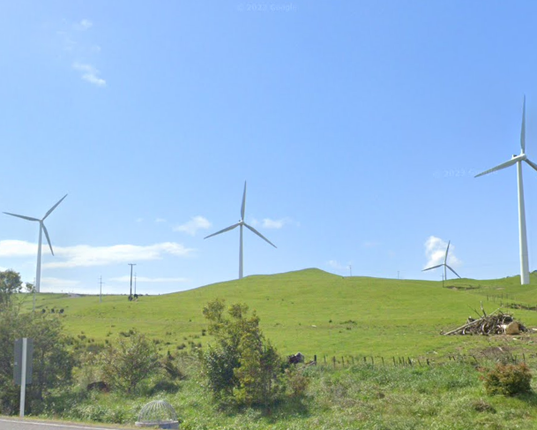
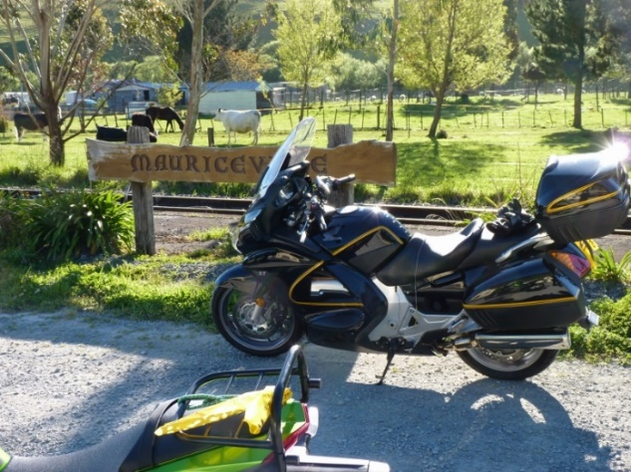

CP 01 - Mauriceville Sign CP 02 – Windmills (from Cooks Rd)

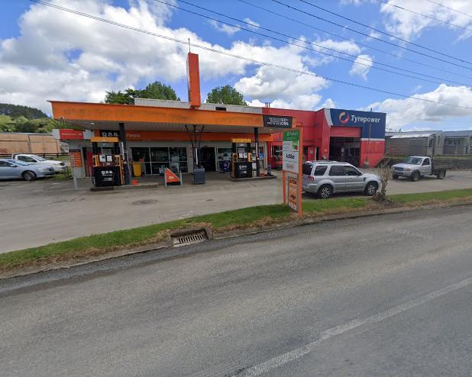
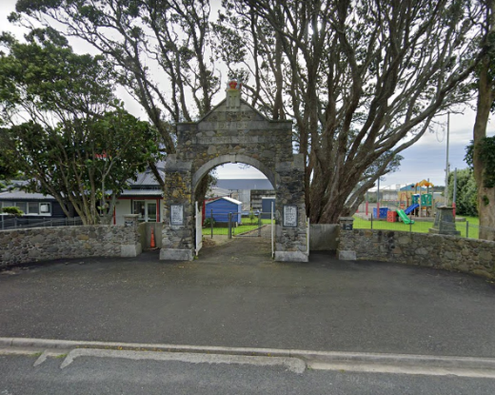

CP 03 - Rahotu School Memorial Gates CP 04 – GAS Piopio
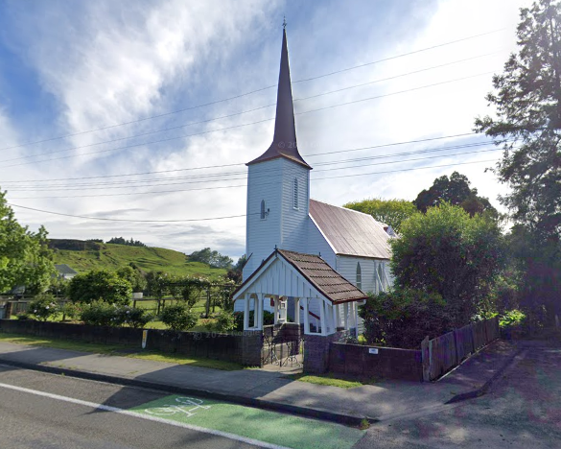
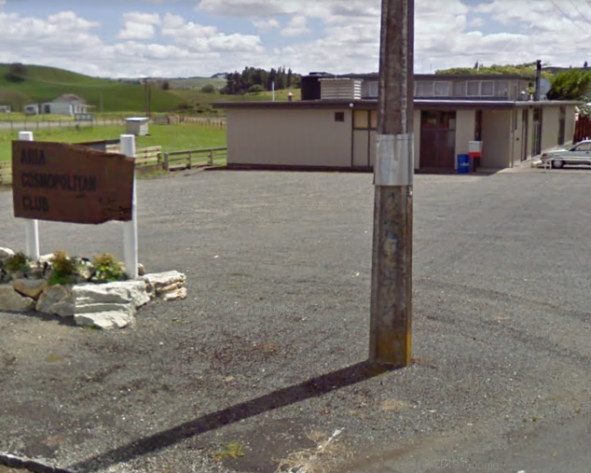

CP 05 – Aria Cossy Club CP 06 – Upok’ Church

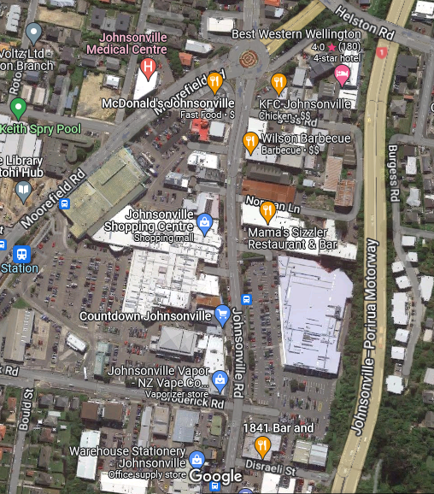
Countdown 1
Motorway exit into Johnsonville
Countdown 2
1841 Restaurant & Bar

The Final Destination – 1841

Get onto Johnsonville Rd, then you can either: enter the Countdown carpark opposite the Mall Entrance; or enter the Countdown carpark from the lights at Broderick Rd; or turn left on Disraeli St then enter the Countdown carpark from beside the 1841.

Exiting North on SH1 – just go back the way you came.

Exiting South to Wellington, or to make your way North on SH2, turn left past the BP to go down the Ngauranga Gorge and follow the signs.
Parking

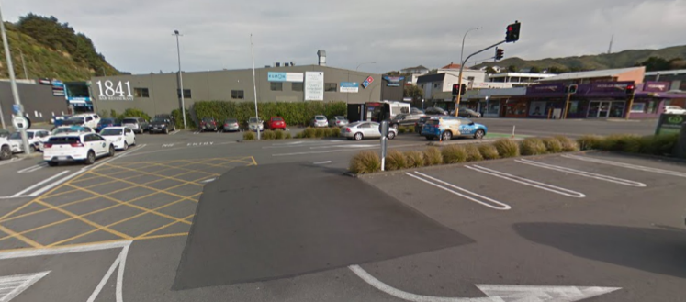
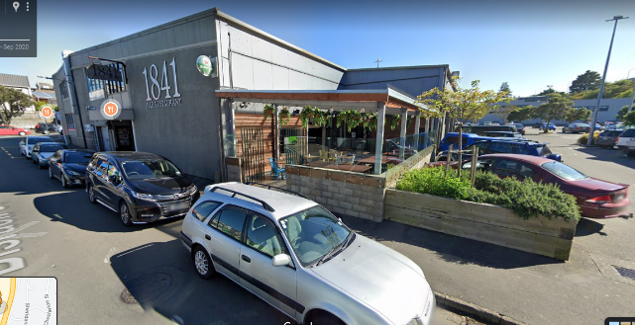
Main Entrance from Disraeli St View coming through Countdown Carpark

